System Design: AtliQ Lead Capture and Follow-up Assistant
Version 1.0 · 11 Oct 2026 · Pankaj Mehta, AI Product Manager
Item | Detail
Status | Describes the prototype as built and deployed (GitHub main, Railway)
Related documents | 03 AI PRD v1.1 (requirements), 04 LLM Cost Estimate v1.1, 06 HAX Assessment
Diagram format | Archify v3.0.1 (github.com/tt-a1i/archify): typed JSON, validated and rendered to interactive HTML. The HTML files sit next to this document.
Source code | github.com/pankajmehta1827/AtliQ-Lead-Capture

1. Purpose and scope
This document explains how the AtliQ Lead Assistant is built: its components, how a conversation becomes a CRM update, which AI models it calls and why, how data is stored and protected, and how it is deployed and measured. It is written for engineers who will extend the prototype and for reviewers who need to approve it for real client data. The product requirements (what and why) are in the AI PRD; this document covers the how.

2. Context and design goals
Sales owners at AtliQ talk to leads over email, meetings and LinkedIn, but the CRM is updated by hand and falls behind. The assistant reads those conversations, proposes the CRM change with evidence, and leaves the final decision to the owner.
Goal | How the design meets it
Human stays in control | The AI only writes drafts. Nothing reaches the deals table until the owner previews and confirms the change (review gate, HAX G16).
Every field is traceable | Each extracted field carries the quote it came from; fields without a matching quote are dropped at the grounding step.
Private data stays private | Exclusion rules run before anything else and wipe the body of skipped items; PII is masked before any LLM call.
Low running cost | Claude Haiku 5.5 at low effort for capture; the input is capped at 6,000 characters per call; Ask AI stays on Groq.
Works without AI | If no key is set, the same graph runs in rules mode, so the app keeps working.
Simple to run | One container (API, worker, scheduler and built frontend) plus PostgreSQL.

3. Architecture overview
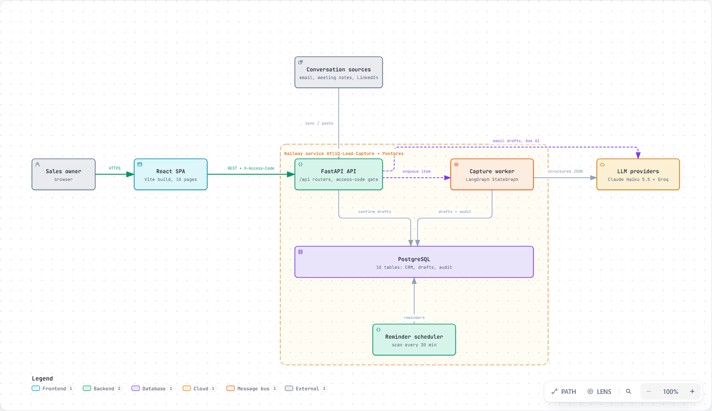
Figure 1. System overview (Archify architecture diagram, interactive version: 07a System Overview.html)
The sales owner uses a React single-page app. It calls a FastAPI backend over REST with an access-code header. Conversations arrive through the API (mailbox sync, file upload or paste) and are stored as queued source items. A capture worker inside the same process picks them up and runs the LangGraph capture pipeline. That pipeline calls the LLM providers for structured JSON and writes drafts and audit entries to PostgreSQL. A reminder scheduler, also in-process, scans deals every 30 minutes and creates follow-up reminders.

3.1 Components
Component | Technology | Responsibility
React SPA | React + TypeScript, Vite | 10 pages: Dashboard, Capture, Review Queue, Pipeline, CRM, Deal detail, Reminders, Summary, Ask AI, Settings.
FastAPI API | FastAPI, Pydantic, uvicorn | REST API under /api, access-code check, serves the built SPA and /health.
Capture worker | asyncio task + LangGraph StateGraph | Polls every 5 s and processes up to 5 queued items per cycle, with retries and rate-limit back-off.
Reminder scheduler | asyncio task | Every 30 min: creates rule-based reminders (commitment due, proposal unanswered 7 days, inactive 14 days, no next step).
PostgreSQL | SQLAlchemy 2 (SQLite locally) | CRM tables, capture queue, drafts, reminders, audit log.
LLM providers | Anthropic SDK, LangChain ChatGroq | Claude Haiku 5.5 for capture and email drafts; Groq gpt-oss-120b for Ask AI (and as the capture option).

4. Capture pipeline
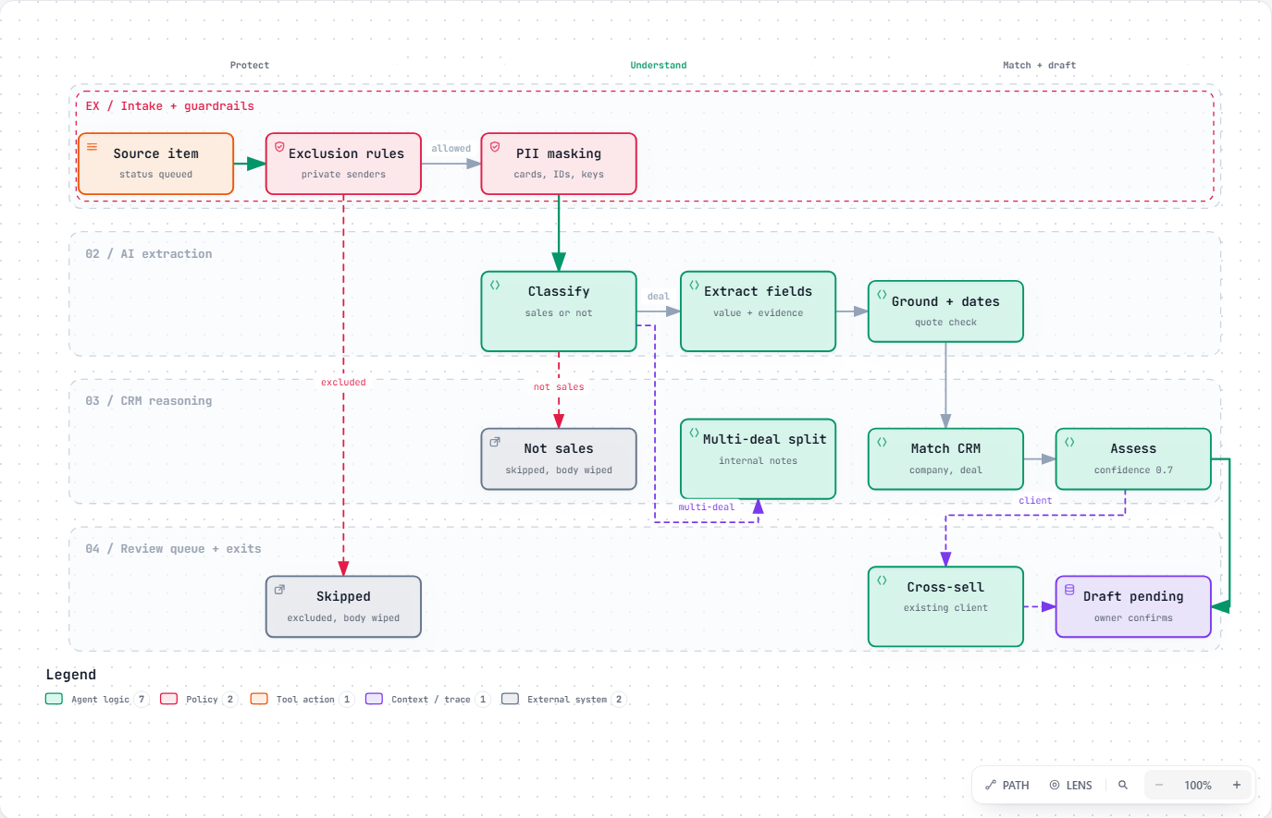
Figure 2. Capture pipeline nodes and branches (Archify workflow diagram, interactive version: 07b Capture Pipeline.html)
The pipeline is a LangGraph StateGraph compiled once at start-up (backend/app/graph/pipeline.py). Each node reads and writes a shared state; conditional edges decide when to stop early.
Step | Type | What it does
check_exclusions | Rule | Matches sender email, domain, subject or keyword rules. A match ends the run as skipped and wipes the body.
mask | Rule | Replaces passwords, API keys, IBAN, bank account, IFSC, card, Aadhaar and PAN numbers with labels before any LLM call.
classify | LLM | New lead, existing deal, existing client, internal multi-deal note, or not sales. Not sales ends the run.
extract | LLM | Company, contact, service, requirement, value, owner, next step, each with value, evidence quote and confidence.
multi_extract | LLM | For internal notes that cover several deals: one draft per deal.
ground | Rule | Drops any field whose evidence quote is not found in the conversation.
dates | LLM | Turns 'next Tuesday' style commitments into dates against the message date.
match | Rule | Finds the company and open deal (domain, normalised name); flags duplicates.
assess | Rule | Scores confidence; drafts below 0.7 or with missing fields are marked needs review.
crosssell | LLM | For existing clients only: suggests other AtliQ services with a rationale.

4.1 AI provider design
Each AI job is routed separately through settings, so a model can be swapped without code changes.
AI job | Provider (live) | Setting | Notes
Capture: classify, extract, dates, multi-deal, cross-sell | Claude Haiku 5.5, effort low | LLM_PROVIDER, CAPTURE_CLAUDE_MODEL / _EFFORT | messages.parse with a Pydantic schema, so output is typed. A refusal becomes a clear item error.
Email drafts | Claude Haiku 5.5, effort low | EMAIL_PROVIDER, EMAIL_CLAUDE_MODEL / _EFFORT | On demand from the deal page. A refusal returns 'please draft it manually'.
Ask AI (questions about the pipeline) | Groq gpt-oss-120b | GROQ_API_KEY, GROQ_MODEL | Always Groq; answers only from CRM data passed in.
No key set | Rules mode | - | Heuristics replace LLM steps; the app still works.

The Claude client pins base_url to api.anthropic.com and uses its own setting names (CAPTURE_CLAUDE_*), so shell variables from developer tools cannot redirect or change it. Temperature is 0 for Groq calls.

5. Data model
Ten tables, created by SQLAlchemy on start-up. JSON columns hold the per-field evidence so the review screen can show where each value came from.
Table | Purpose | Key columns
companies | Client and prospect companies | name, normalized_name, domain
contacts | People at those companies | company_id, name, email
deals | One lead or opportunity | lead_code, status, est_value_usd, owner, next_followup_date, next_step
source_items | Captured conversations (the queue) | channel, external_ref (unique), body, status, attempts, last_error
drafts | Proposed CRM writes awaiting review | kind, fields (value, evidence, confidence), confidence, needs_review, status, owner, llm_mode
deal_activities | Timeline linking a deal to the conversation | deal_id, source_item_id, draft_id, changes
reminders | Follow-ups for the owner | deal_id, kind, due_date, evidence, status
crosssell_suggestions | Service ideas for existing clients | deal_id, service, rationale, status
exclusion_rules | Senders or topics never to process | rule_type, value
audit_log | Every action by a user or the assistant | ts, actor, action, entity, outcome, details

5.1 State lifecycle
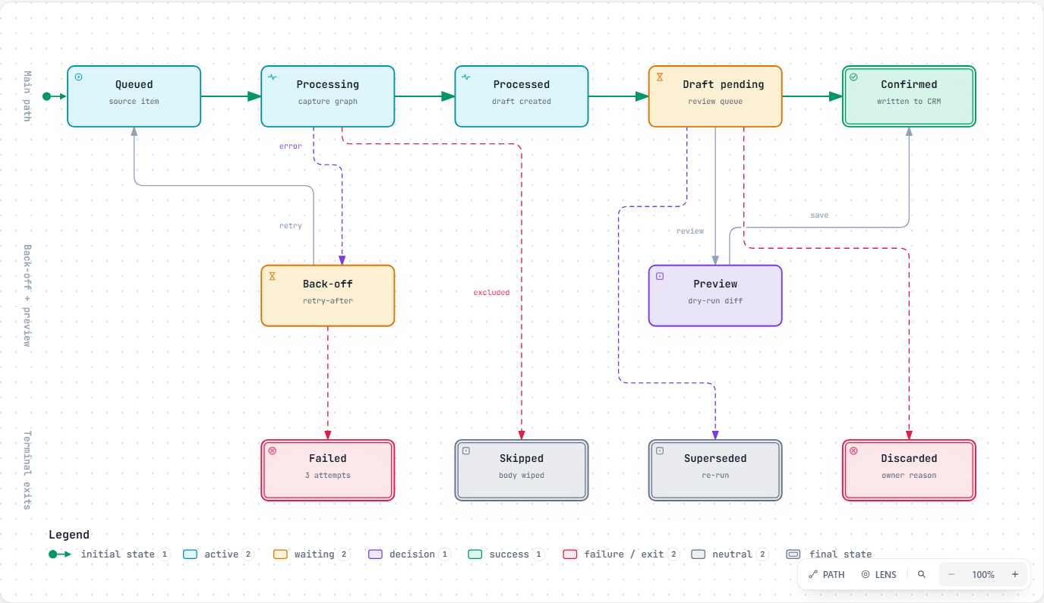
Figure 3. Source item and draft states (Archify lifecycle diagram, interactive version: 07c Item and Draft Lifecycle.html)
- Source item: queued → processing → processed, skipped (excluded or not sales, body wiped) or failed (after 3 attempts). Errors and rate limits return the item to the queue after a back-off that honours the provider's retry-after header.
- Draft: pending → confirmed (writes the deal, a timeline activity, reminders and cross-sell ideas) or discarded (reason kept for evals). Re-running an item supersedes its old pending draft.
- Preview is a dry run of confirm: it shows the exact change, then rolls back.

6. API surface
Router | Prefix | Main endpoints
capture | /api/capture | POST '' (paste), /upload, /sample (mailbox sync), /process; GET /items; POST /items/{id}/retry; GET/POST /rerun
drafts | /api/drafts | GET list and one; POST /{id}/preview, /{id}/confirm, /{id}/discard
pipeline | /api | GET/PATCH /deals; /reminders (+ scan, resolve); /crosssell; /summary/daily
crm | /api/crm | GET/POST /leads; GET /export; POST /import; GET /sync
ai assist | /api | POST /deals/{id}/email-draft, /ask, /feedback
admin | /api | GET /config, /me, /audit, /metrics; exclusions CRUD; POST /admin/processing

Every request needs the X-User header (the acting seller) and, when APP_ACCESS_CODE is set, a matching X-Access-Code header (constant-time compare).

7. Security and privacy
Risk | Control
Private or personal conversations processed | Exclusion rules run first; skipped and non-sales items keep no body.
Sensitive numbers sent to an AI provider | Regex masking of 8 PII and secret types before any LLM call.
AI writes wrong data to the CRM | Drafts only; owner preview and confirm; evidence quote per field; grounding drops unsupported fields.
Unauthorised access | Shared access code over HTTPS (prototype). Replace with SSO before real client data.
Secrets leaking | Keys only in environment variables (Railway variables, local .env not committed).
No accountability | audit_log records every capture, confirm, discard, edit, reminder scan and AI feedback.

8. Reliability and error handling
- Retries: an item that fails is re-queued up to 3 attempts, then marked failed with a friendly error the user can retry from the Capture page.
- Rate limits: the worker pauses for the provider's retry-after time instead of failing items.
- Refusals: a Claude refusal (stop_reason refusal) is reported as a clear error, never as an empty draft.
- Idempotency: external_ref is unique, so syncing the same mailbox twice does not create duplicates.
- Degraded mode: with no AI key the rules pipeline keeps capture running at lower quality.
- Processing can be paused from Settings (POST /api/admin/processing) without stopping the app.

9. Deployment and environments
Environment | How it runs | Database
Local, no Docker | python backend/run_local.py (API + built frontend) | SQLite file
Local, Docker | docker compose up (app + postgres) | PostgreSQL container
Production prototype | Railway service AtliQ-Lead-Capture, auto-deploys from GitHub main via the Dockerfile | Railway PostgreSQL

The Dockerfile builds the frontend and serves it from FastAPI, so there is one service to deploy. Configuration is environment variables only (see .env.example).
Live demo: https://atliq-lead-capture-production.up.railway.app

10. Observability and evaluation
- GET /health for uptime checks; start-up log shows which provider handles capture, email drafts and Ask AI.
- GET /api/metrics: North Star (new leads confirmed within 24 hours with source, requirement and next step), minor-edit rate on confirmed drafts, open deals with a next step, inactive deals and review-queue age.
- AI feedback (thumbs up or down) is stored in audit_log as ai_feedback.
- Golden eval set: 65 labelled conversations and 12 Ask AI questions, run through the production path by backend/evals/run_golden.py (rules or LLM mode, resumable).
Eval measure (Groq run, 41 of 65) | Result | Target
Sales detection precision / recall | 97.2% / 100% | ≥ 95%
CRM matching (wrong merges) | 100% (0) | 0 wrong merges
Field accuracy | 82.8% | 90%
Follow-up date accuracy | 90.3% | 90%
Private data leaks | 0 | 0

Known gap: threads longer than 6,000 characters are cut, so late facts in long threads can be missed.

11. Scaling and next steps
Area | Today | When it is needed
Worker | In-process asyncio task, 5 items per cycle | Move to a separate Railway worker service when volume passes a few thousand items a day.
Queue | source_items table polled by status | Use SKIP LOCKED or a message queue once there is more than one worker.
Mailbox | Sample mailbox sync and upload | Gmail / Outlook connector with per-user OAuth.
Long threads | 6,000-character cap | Chunk and summarise threads before extraction.
Authentication | Shared access code | SSO with per-user roles before real client data.
Cost control | Low effort, capped input | Prompt caching for the fixed system prompts; batch API for back-fills.

12. About the diagrams
The three diagrams were authored in the Archify format: each is a typed JSON file (architecture, workflow and lifecycle schemas) that Archify validates, renders to a standalone HTML page with inline SVG, and checks in a real browser. All three passed the validate, deliver, check and browser-check gates. The HTML versions support light and dark themes, path tracing and export to PNG or SVG; the JSON sources are kept in the diagrams folder so they can be edited and re-rendered.
Archify: https://github.com/tt-a1i/archify

